WORKSHEET ONE DOCUMENTATION

MINHAL AHMED FAYAZ

UWE ID : 21080460

CLONING

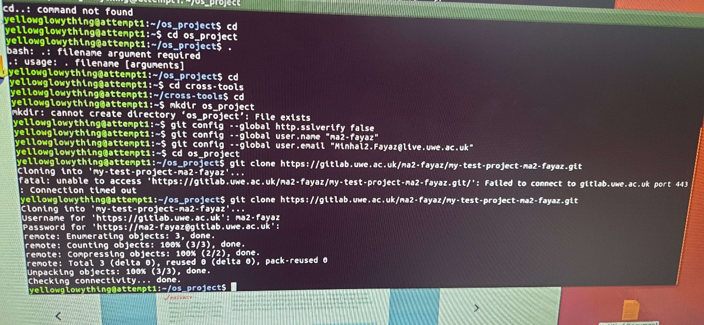

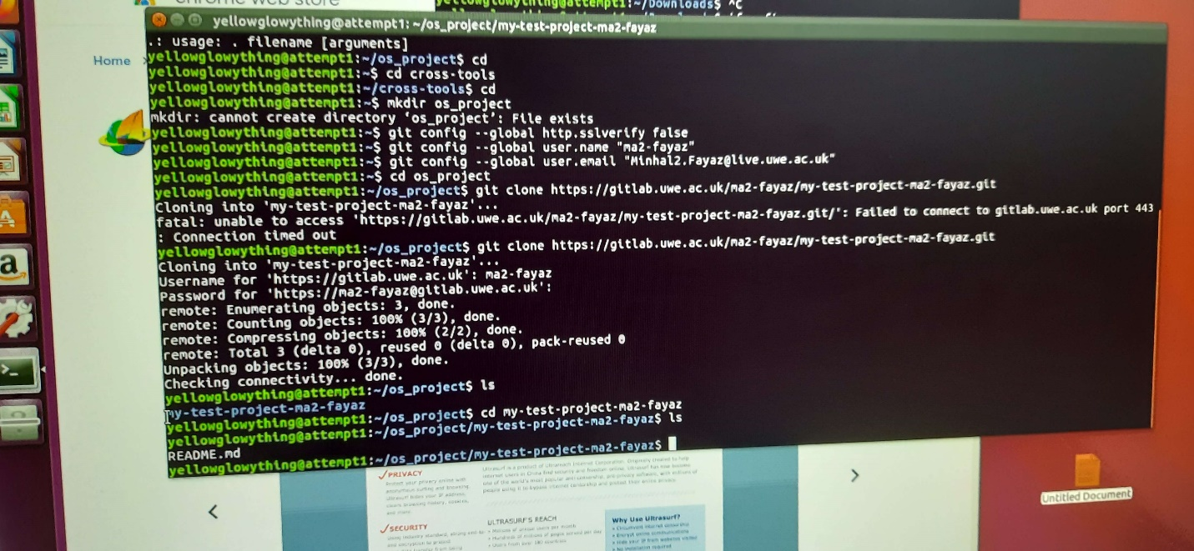

MAKING NEW README

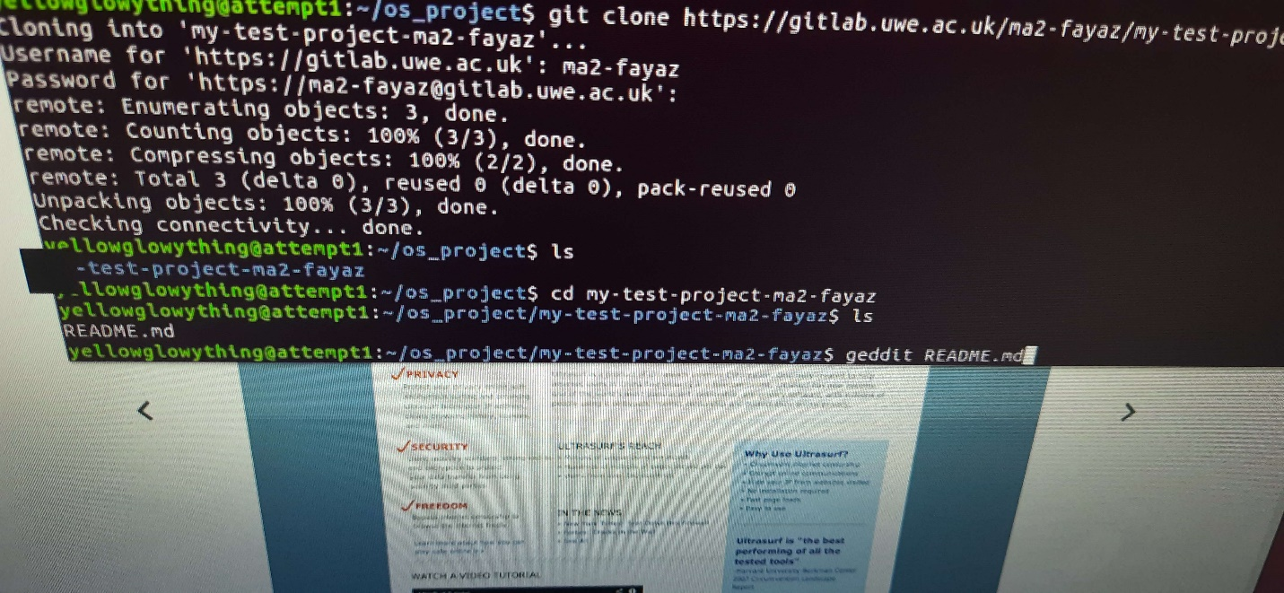

PUSHING NEW README

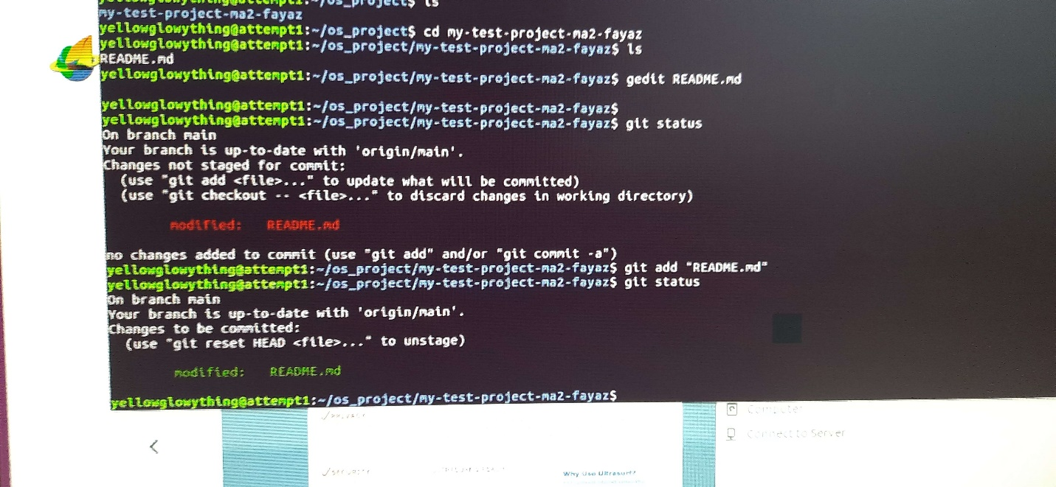

FINAL STATUS OF GITLAB PROJECT

